Switch

🔌 What is a Switch?
# Source: AI Source: Provided by: [Data Path: Persons Table -> ID Column: 1, Name_En Column: Motasem Essam] -> From: [ChatGPT] on [12/18/2025]
A network switch is a device used in a Local Area Network (LAN) to connect multiple devices (like computers, printers, servers) and direct data only to the device it's intended for.
Unlike a hub (which sends data to all connected devices), a switch is intelligent: it learns the MAC address of each device and forwards data only to the correct port.

🔧 Key Functions of a Switch
# Source: AI Source: Provided by: [Data Path: Persons Table -> ID Column: 1, Name_En Column: Motasem Essam] -> From: [ChatGPT] on [12/18/2025]
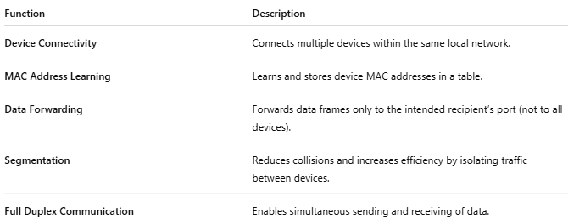

Function | Description
Device Connectivity | Connects multiple devices within the same local network.
MAC Address Learning | Learns and stores device MAC addresses in a table.
Data Forwarding | Forwards data frames only to the intended recipient’s port (not to all devices).
Segmentation | Reduces collisions and increases efficiency by isolating traffic between devices.
Full Duplex Communication | Enables simultaneous sending and receiving of data.

📶 How It Works
# Source: AI Source: Provided by: [Data Path: Persons Table -> ID Column: 1, Name_En Column: Motasem Essam] -> From: [ChatGPT] on [12/18/2025]
- A device sends data to another device on the network.
- The switch reads the destination MAC address.
- It checks its internal MAC address table.
- It forwards the data only to the correct port (where the target device is connected).

🏠 Example: Small Office Network with a Switch
# Source: AI Source: Provided by: [Data Path: Persons Table -> ID Column: 1, Name_En Column: Motasem Essam] -> From: [ChatGPT] on [12/18/2025]
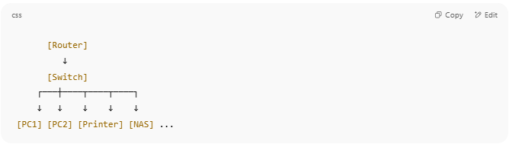

[Router]
↓
[Switch]
┌───┼────┬────┬────┐
↓ ↓ ↓ ↓ ↓
[PC1] [PC2] [Printer] [NAS] ...

All devices can talk to each other efficiently without broadcasting everything.

🧱 Types of Switches
# Source: AI Source: Provided by: [Data Path: Persons Table -> ID Column: 1, Name_En Column: Motasem Essam] -> From: [ChatGPT] on [12/18/2025]
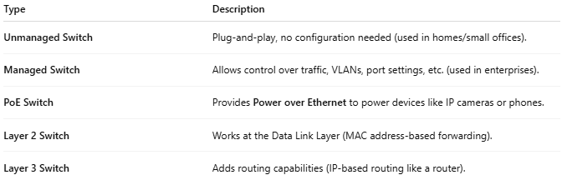

Type | Description
Unmanaged Switch | Plug-and-play, no configuration needed (used in homes/small offices).
Managed Switch | Allows control over traffic, VLANs, port settings, etc. (used in enterprises).
PoE Switch | Provides Power over Ethernet to power devices like IP cameras or phones.
Layer 2 Switch | Works at the Data Link Layer (MAC address-based forwarding).
Layer 3 Switch | Adds routing capabilities (IP-based routing like a router).

🆚 Switch vs Hub vs Router
# Source: AI Source: Provided by: [Data Path: Persons Table -> ID Column: 1, Name_En Column: Motasem Essam] -> From: [ChatGPT] on [12/18/2025]
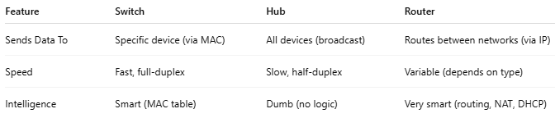

Feature | Switch | Hub | Router
Sends Data To | Specific device (via MAC) | All devices (broadcast) | Routes between networks (via IP)
Speed | Fast, full-duplex | Slow, half-duplex | Variable (depends on type)
Intelligence | Smart (MAC table) | Dumb (no logic) | Very smart (routing, NAT, DHCP)

